**Keyboard Sync Block**

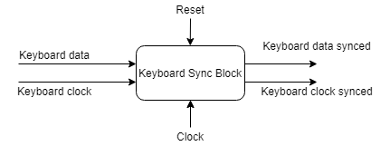

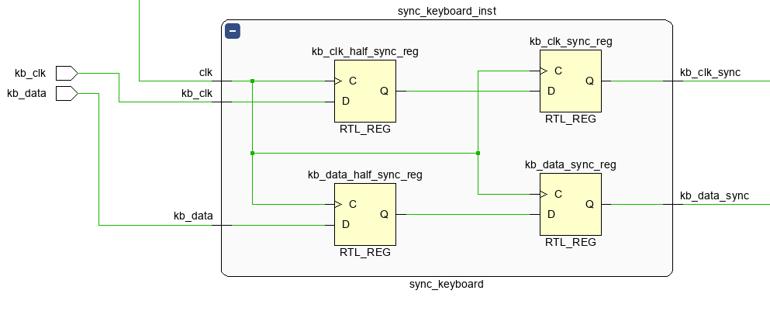

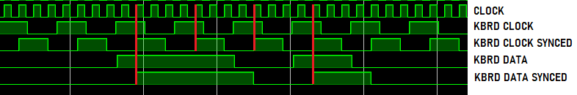

Synchronization using two 2 D-FF in series for each signal